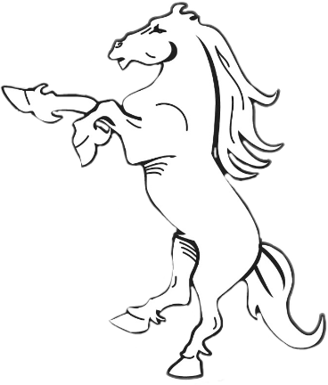
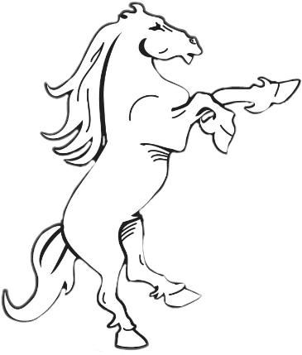
Welcome!
Welcome to Generation Hatton, the monthly magazine updating you on all things Sir Christopher Hatton Academy.
Select a month down below to see a range of articles, art, and news, handwritten by our sixth-form volunteers!

